DATA SCIENCE AND VISUALIZATION (24ADI204)
DEPARTMENT OF ARTIFICIAL INTELLIGENCE AND DATA SCIENCE
Team 16
WEEK 4 PROJECT REPORT
“Crime Hotspot Mapping”
“Night Watch: Visualizing Crime Patterns for Safer Cities”
TASK: EDA DEEP DIVE – UNIVARIATE AND BIVARIATE ANALYSIS
Team Members: 25BAD041 Jyothika Conoor Ramesh
25BAD045 Keerthi Samyuktta J
Faculty Guide: Ms. Rupashini
Ms. Shriaarthy E

1. Objective
The objective of Week 4 was to perform an Exploratory Data Analysis (EDA) deep dive on the cleaned dataset. The analysis focused on understanding individual variables through univariate analysis and examining relationships between two variables through bivariate analysis. The work was carried out using three visualizations for each analysis type. The cleaned dataset contains socio-economic, demographic and health indicators for countries around the world together with the homicide rate, which is the crime indicator that this analysis centres on.

2. EDA Methodology
The dataset was first loaded and inspected using shape, information, null-value counts, duplicate checks, descriptive statistics, and a list of columns. The analysis was then divided into univariate and bivariate stages.
- Univariate Analysis: examined the distribution of the homicide rate, the number of countries per region, and the shape of six key socio-economic indicators.
- Bivariate Analysis: examined the correlations between all numeric variables, the relationship between homicide rate and four key indicators, and homicide rate by region.
- Visualization: used histograms with a box plot, count plots, a correlation heatmap, scatter plots, and bar plots.

Dataset overview | Details
Size of raw file | 204 rows × 20 columns
Duplicate rows | 12 exact duplicates found and removed, leaving 192 unique countries
Missing values | None (0 null values in every column)
Variables | 17 numeric (including homicide_rate) and 3 text columns (name, region, iso2)
Regions | 22 world regions
Derived feature | homicide_level: Low (≤2), Moderate (>2–10), High (>10–20), Very high (>20)

Data-quality notes. Three points were found during inspection and are carried through the report:
- Duplicates: each of the 12 affected countries appeared twice. They were removed so that no country is counted twice.
- ISO code error: Namibia is recorded with the code “AD”, which belongs to Andorra (Namibia’s code is “NA”). It does not affect this analysis but should be corrected before map-based work.
- Repeated median values: the CO2 value 31.3 appears for 57 countries (30%) and the homicide rate 2.5 appears for 26 countries (14%). Both are the column median, which is consistent with median imputation of missing values during cleaning. The data was analysed as provided, and a sensitivity check (Section 4) confirms the conclusions hold without these rows.

3. Univariate Analysis
Univariate analysis examines one variable at a time to understand its distribution, frequency, and basic characteristics. Most numeric variables in this dataset are right-skewed (for example population density 12.0, CO2 emissions 9.7, population 8.4 and GDP per capita 3.7), so the median is reported alongside the mean.

3.1 Histogram and box plot: homicide rate
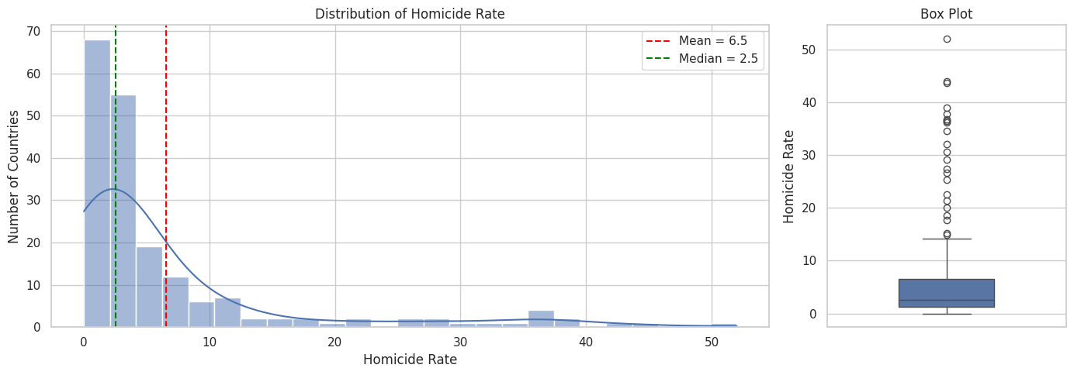
Figure 1. Distribution of homicide rate with mean, median and box plot
The distribution is strongly right-skewed (skewness 2.5). The mean (6.5) is far above the median (2.5), and 75% of countries have a rate of 6.6 or below, yet the maximum reaches 52.0 (El Salvador). A total of 23 countries lie above the upper outlier fence of 14.4. The tall bar near 2.5 is partly the 26 countries that share exactly that value (Section 2).
Homicide level | Countries | Share
Low (≤2) | 68 | 35.4%
Moderate (>2–10) | 91 | 47.4%
High (>10–20) | 14 | 7.3%
Very high (>20) | 19 | 9.9%

3.2 Count plot: countries per region
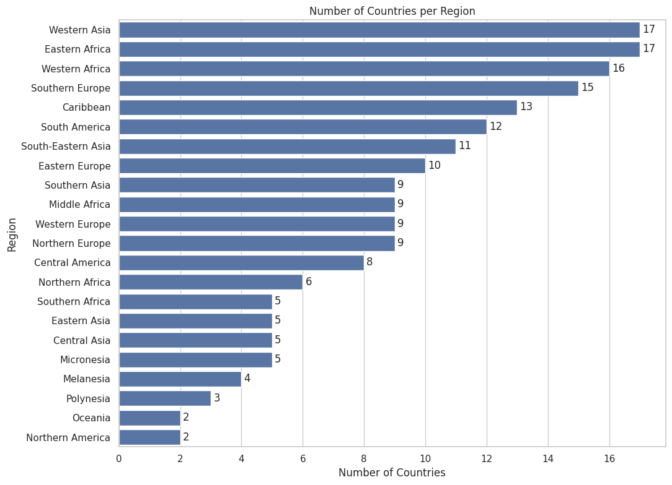
Figure 2. Number of countries in each of the 22 regions
The 192 countries are spread unevenly over 22 regions. Western Asia and Eastern Africa are the largest (17 countries each), followed by Western Africa (16), Southern Europe (15) and the Caribbean (13). Northern America and Oceania have only 2 countries each, so regional averages for these small regions should be read with caution.

3.3 Histograms: key socio-economic indicators
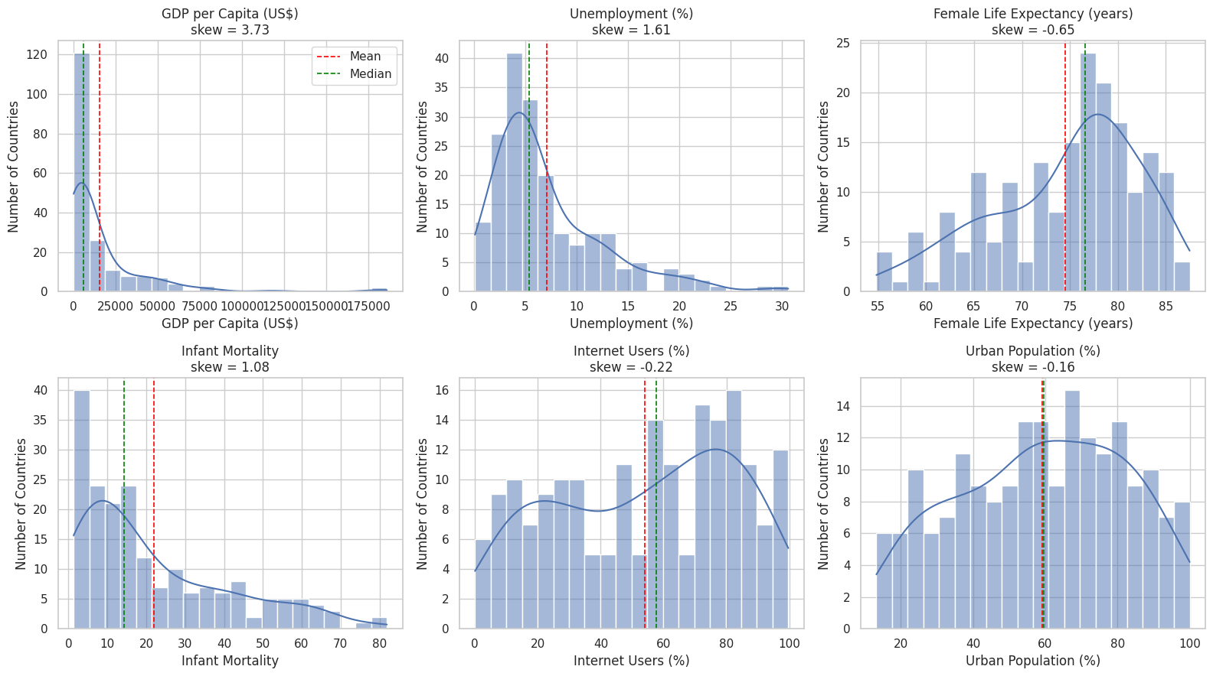
Figure 3. Distribution of six key indicators with mean (red) and median (green)
The six indicators have very different shapes. GDP per capita is extremely right-skewed (3.7): the mean of about US$15,500 is nearly three times the median of about US$5,900, because a few wealthy economies stretch the tail. Unemployment (1.6) and infant mortality (1.1) are also right-skewed. Female life expectancy is left-skewed (−0.65), with about two-thirds of countries between 70 and 85 years. Internet use is spread widely across the 0–100% range, while urban population is close to symmetric (mean 59.1, median 59.5).

4. Bivariate Analysis
Bivariate analysis examines the relationship between two variables to identify patterns, associations, and differences between groups. Both the linear (Pearson) and the rank-based (Spearman) correlation are reported, because the skewed distributions make the Pearson value alone misleading.

4.1 Heatmap: correlations between numeric variables
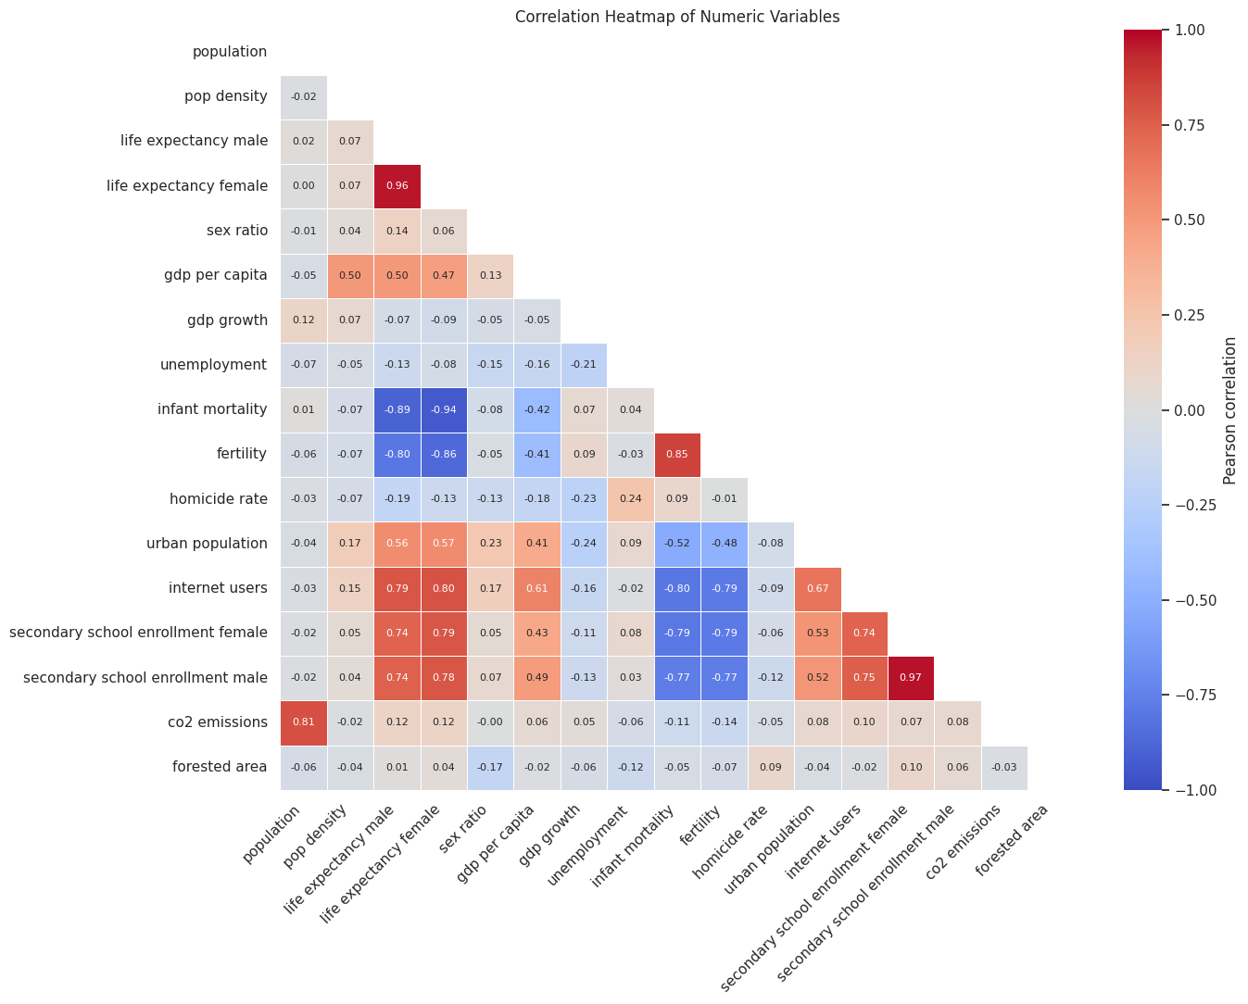
Figure 4. Pearson correlation heatmap of the 17 numeric variables
Many indicators are strongly linked to each other: male and female school enrollment (0.97), male and female life expectancy (0.96), female life expectancy and infant mortality (−0.94), infant mortality and fertility (0.85), and population and CO2 emissions (0.81). This overlap should be kept in mind before any modelling.
The homicide rate is only weakly correlated with every other variable. On the Pearson scale the largest values are unemployment (+0.24) and GDP growth (−0.23). The Spearman correlation, which is less affected by extreme values, is somewhat stronger: male life expectancy (−0.43), infant mortality (+0.41), internet users (−0.37), fertility (+0.34) and GDP per capita (−0.33).

4.2 Scatter plots: homicide rate against key indicators
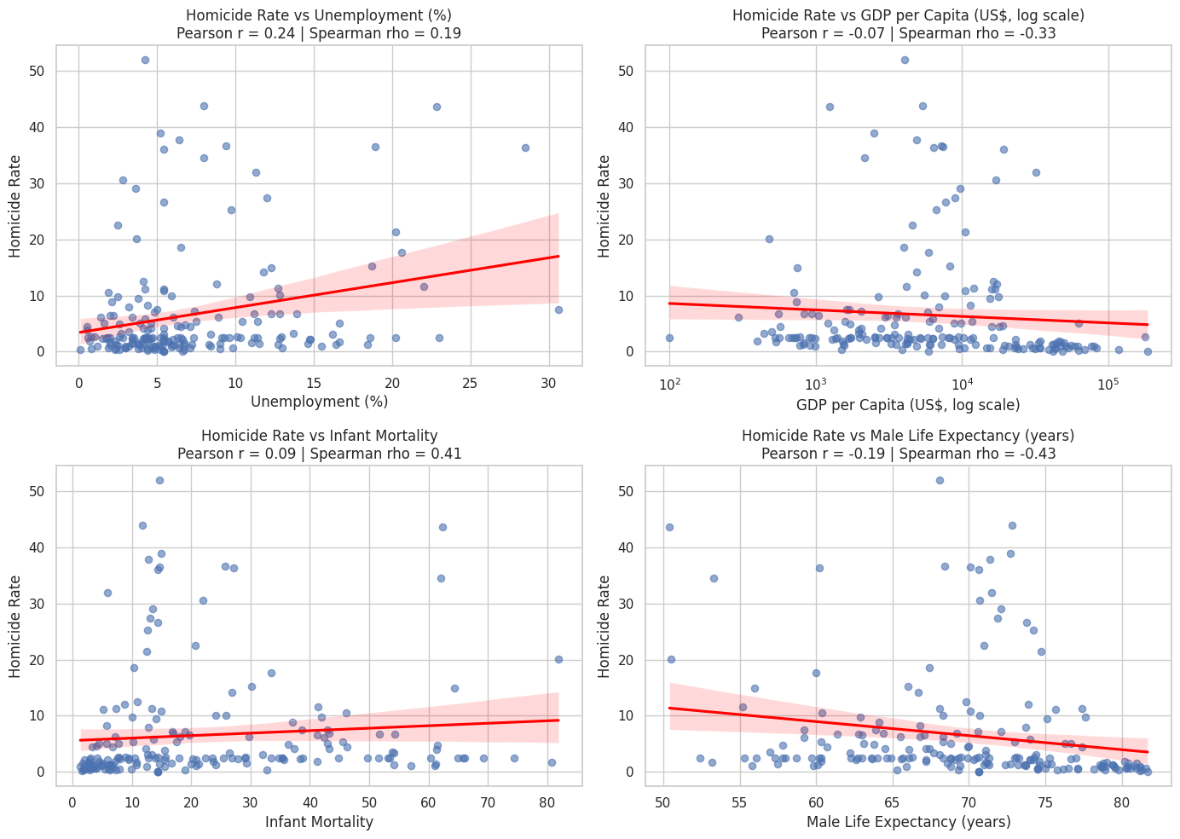
Figure 5. Homicide rate vs unemployment, GDP per capita, infant mortality and male life expectancy
All four relationships are weak to moderate, with wide scatter around each trend line. Homicide tends to be lower where male life expectancy (Spearman −0.43) and GDP per capita (−0.33) are higher, and higher where infant mortality (+0.41) and unemployment (+0.19) are higher. For GDP per capita and infant mortality the Pearson values (−0.07 and +0.09) are much weaker than the Spearman values, so the link is not a straight line: the highest rates come from a cluster of middle-income countries rather than from the poorest. The flat band of points at 2.5 in every panel is the repeated median value.

4.3 Bar plot: homicide rate by region
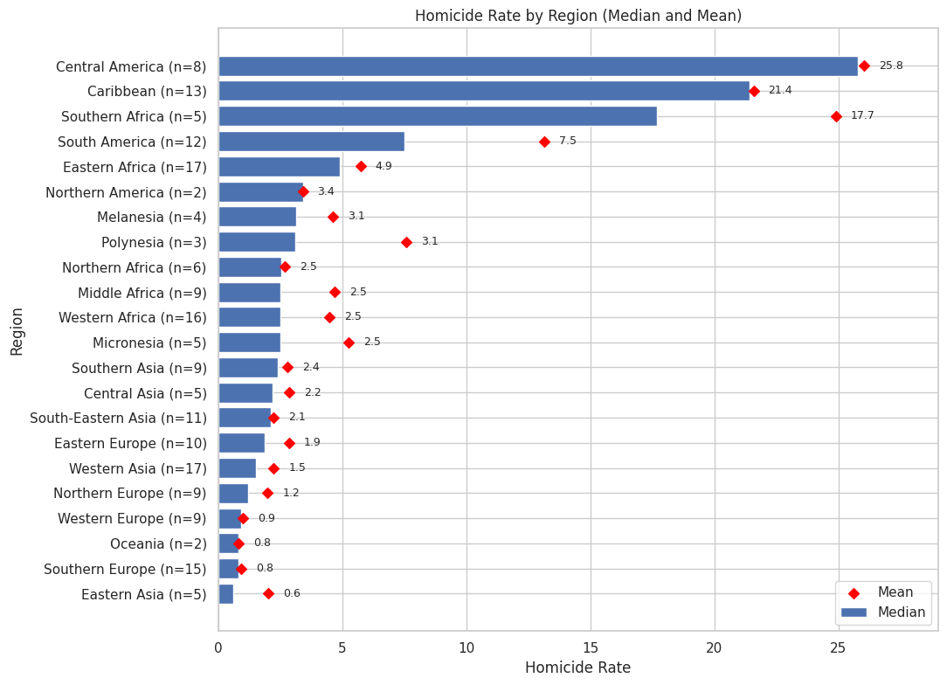
Figure 6. Median (bars) and mean (diamonds) homicide rate by region
Region explains far more of the pattern than any single indicator. Four regions stand well above the rest by median homicide rate: Central America (25.8), the Caribbean (21.4), Southern Africa (17.7) and South America (7.5). Eastern Africa follows at 4.9 and every other region is at 3.4 or below, with Eastern Asia (0.6), Southern Europe (0.8) and Western Europe (0.9) the lowest. Central America’s median is roughly 29 times that of Western Europe. In Southern Africa and South America the mean is well above the median (24.9 vs 17.7 and 13.2 vs 7.5), so a few countries pull those regions up. These four regions contain 19 of the 23 outlier countries. Medians of exactly 2.5 for Middle Africa, Western Africa and Micronesia equal the dataset median and are likely placeholders rather than measured values.
Sensitivity check. When the 26 countries with the repeated homicide value of 2.5 are excluded (166 countries remain), all 23 outliers remain, the top three regions keep the same medians, and the correlations become slightly stronger rather than weaker (male life expectancy −0.43 to −0.48, infant mortality +0.41 to +0.46). The repeated values therefore dilute the relationships a little but do not create them.

5. Key Findings
- Homicide is highly unequal across countries. The distribution is right-skewed (median 2.5 vs mean 6.5), with 23 outlier countries above 14.4 and a maximum of 52.0 (El Salvador).
- Most indicators are skewed, not bell-shaped. GDP per capita, population, CO2 emissions and population density have long right tails, so medians describe a typical country better than means.
- Indicators overlap heavily with each other, but not with homicide. Life expectancy, infant mortality, fertility and internet use move together, while homicide has only weak correlations with each of them (|Pearson| at most 0.24, |Spearman| at most 0.43).
- Higher homicide goes with weaker development on average: lower life expectancy, higher infant mortality, lower GDP per capita and higher unemployment. These are tendencies with wide scatter, not predictors.
- Geography is the strongest pattern. Central America, the Caribbean, Southern Africa and South America hold 19 of the 23 outliers and have by far the highest regional medians, which supports treating region as the natural hotspot unit.
- Data quality needs attention. The repeated median values (homicide 2.5 for 26 countries, CO2 31.3 for 57 countries) and the Namibia ISO-code error should be checked against the raw data. The conclusions above are unchanged without the repeated homicide values.

6. Conclusion
Week 4 completed the EDA deep dive on the cleaned dataset. The univariate analysis described the distribution of the homicide rate, the spread of countries across regions and the shape of six key socio-economic indicators, while the bivariate analysis examined how homicide relates to those indicators and to region. The results show that homicide is concentrated in a small set of regions and countries and is not explained by any single socio-economic variable. These visualizations provide a clear analytical foundation for the hotspot-focused analysis and dashboard development in the coming weeks. Before map-based work begins, the Namibia ISO code should be corrected and the repeated median values should be verified.

